How to Generate a Closing Protection Letter
- Login to the website at www.fidelitydesktop.com
- Click Generate CPL Order
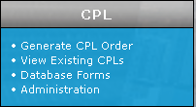

- Fill out the information for each step, BOLD fields are required
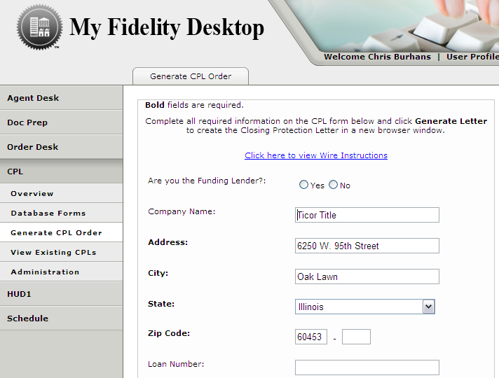

- Push Generate Letter at the bottom

- The Closing Protection Letter will open in a new window

